JiS QMS Audit 2020
Accountant
Before follow up, 100
After follow up, 90%
10% follow up 2 weeks,
It has to be transferred to HO
2020
45% of 100%
This year calls not started, will start next month
10 to 15k wait for bank deposit
Petty cash 30k
Insurance 150k
Overtime for teachers
15% for lumpsump
10% of 7 weeks for self + 15%
First semester 80%
2 pending petty cash
1 preparing
25 buses
6 driver missing because of SAMASCO
First aid by petty cash
Bm
maintains budget and reconciliation
No reconciliation
Cleaning/Maintenance
Plan is there but not started
Nestor

Transport
Discipline with Mr Ozair
Sameh doesn't provide what he fixed
They just send request

Parents coordinator
Stats not available
Follow-up after resolution is not there or require addition
Possibly format
She provides suggestions
Multifaceted communication
Majorly phone

Registrar
1280 current
109 withdrawal
6 convinced join back

HSEQ

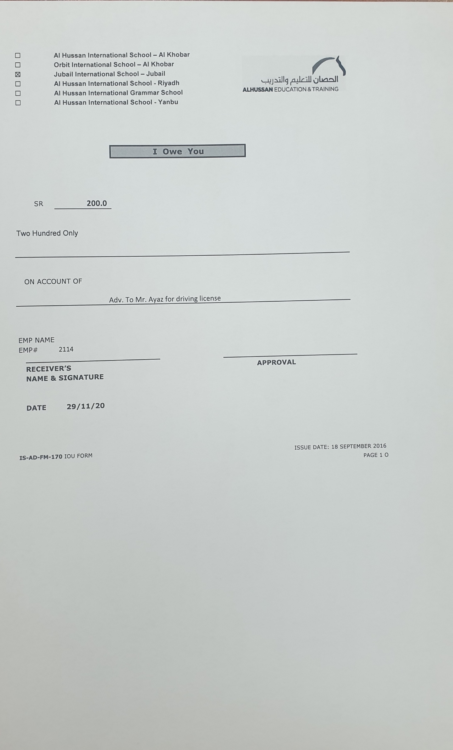

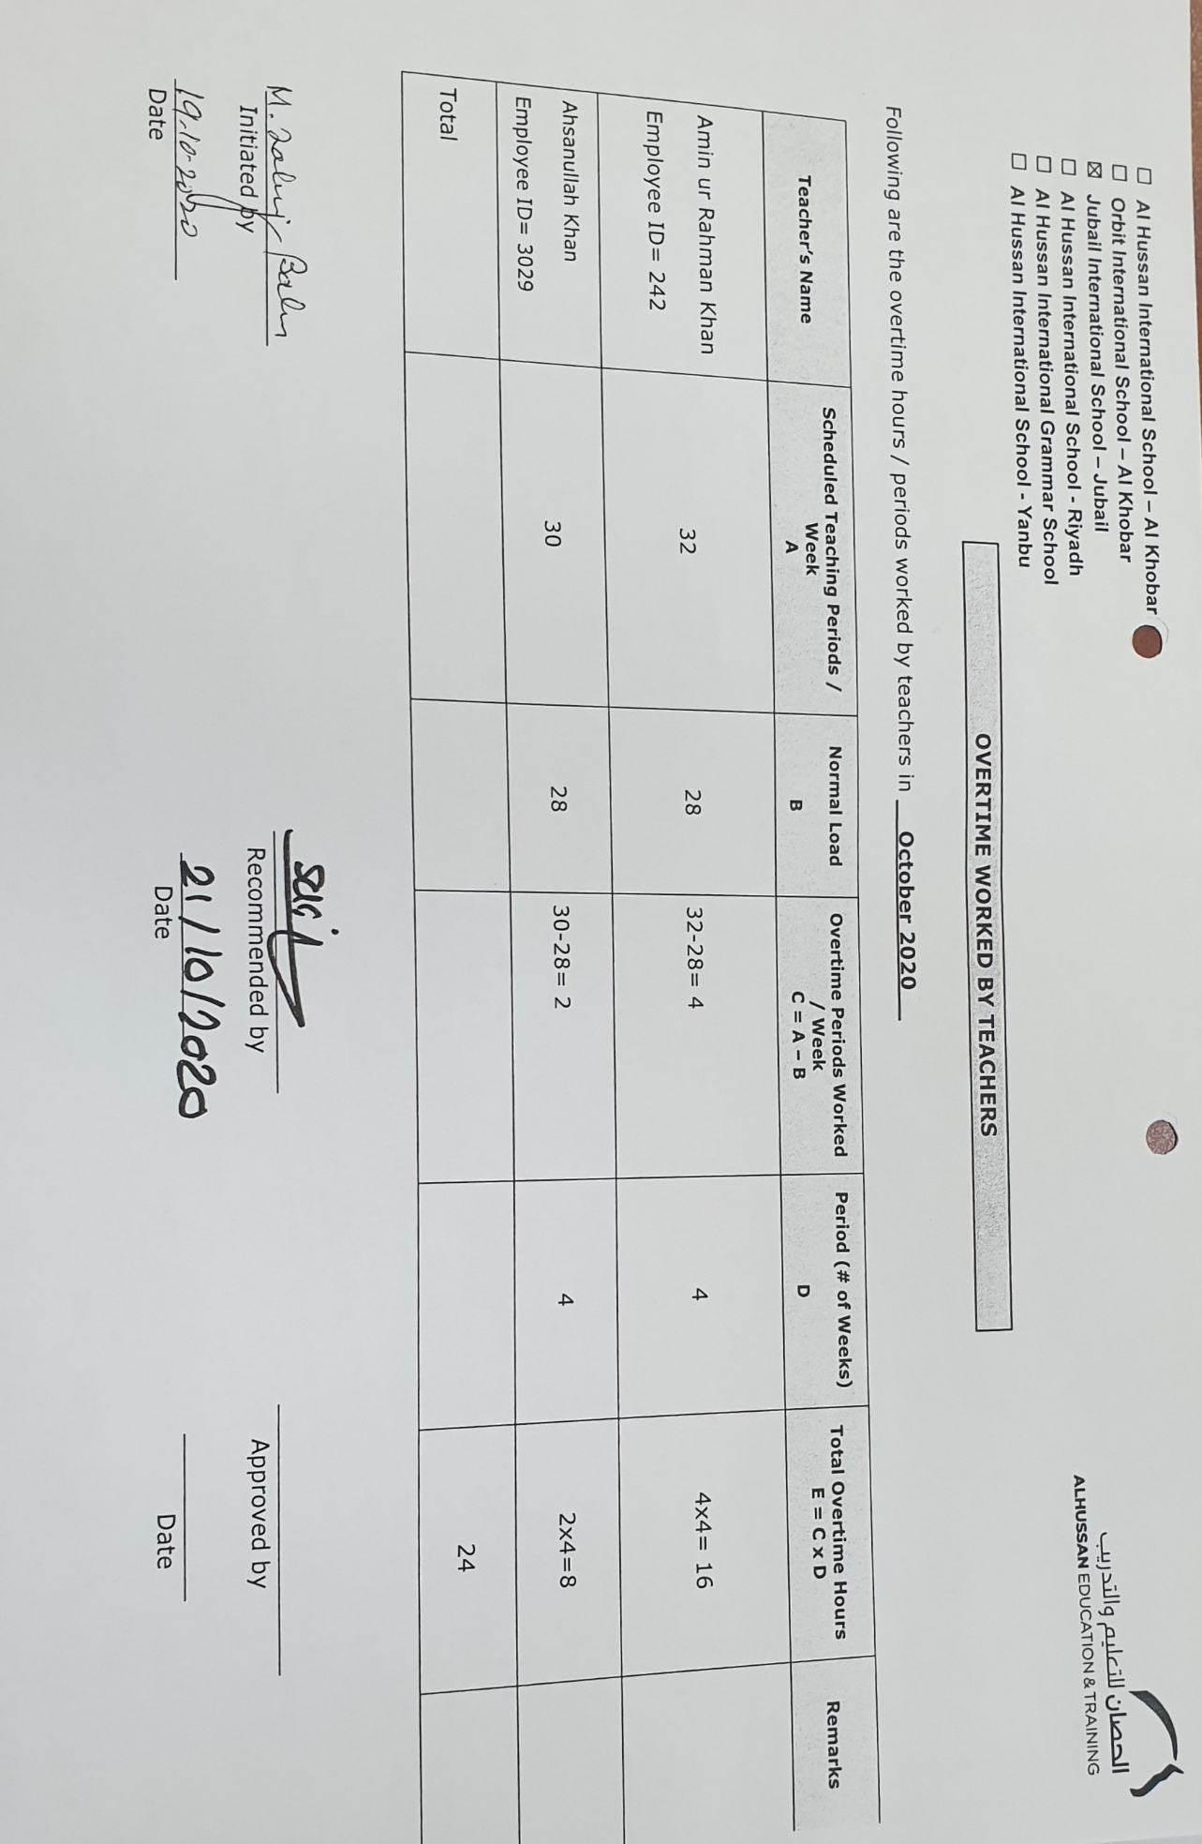

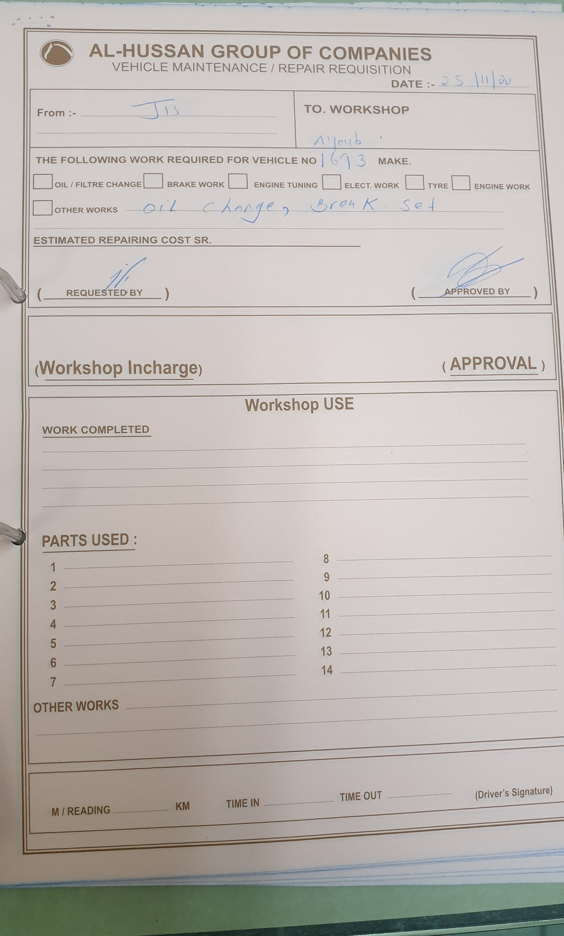

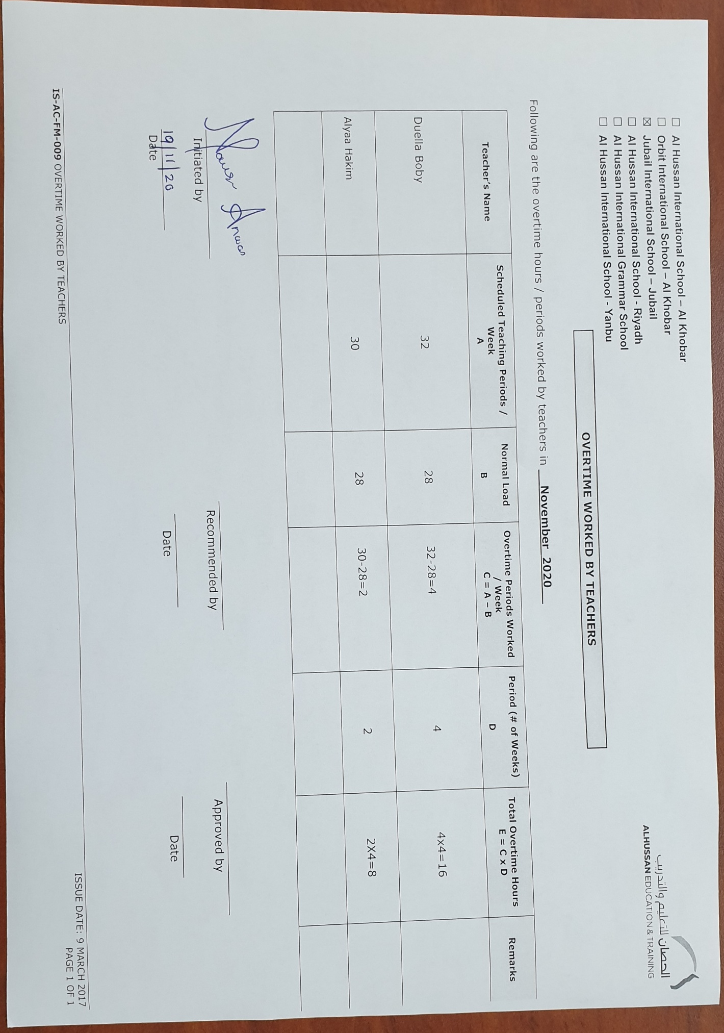
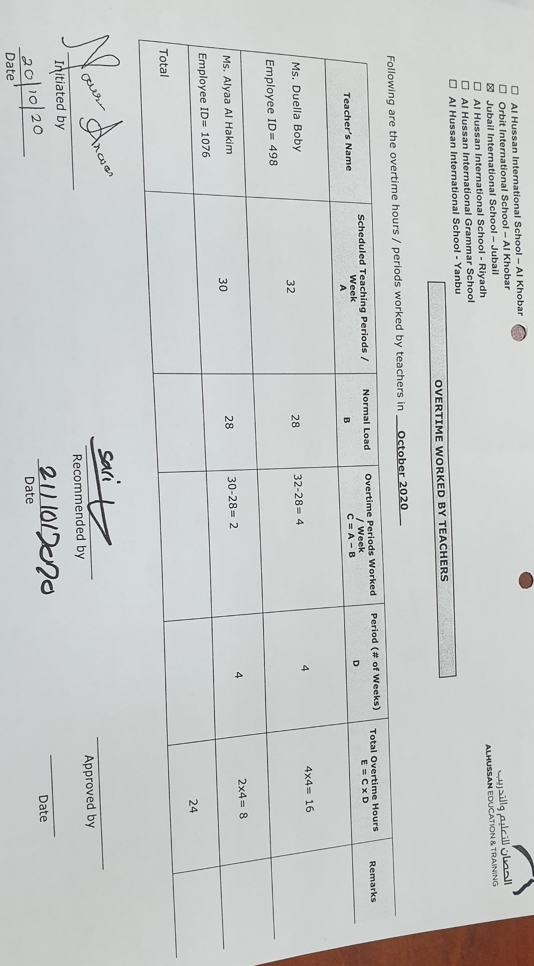

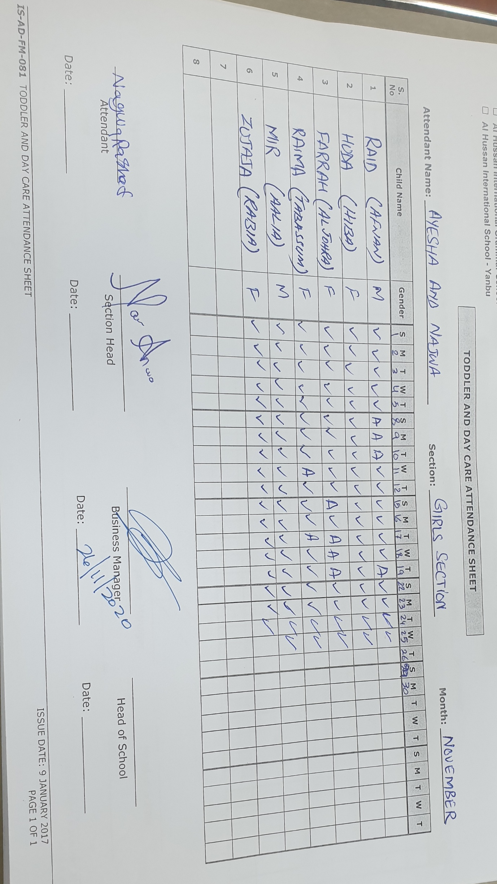

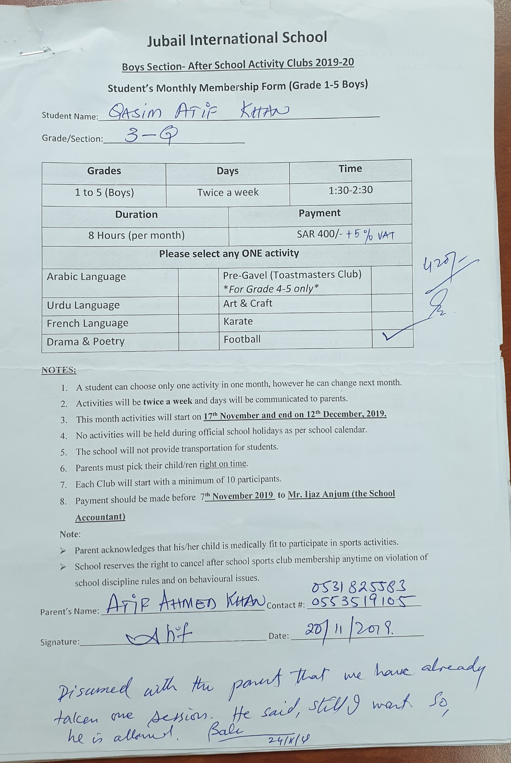
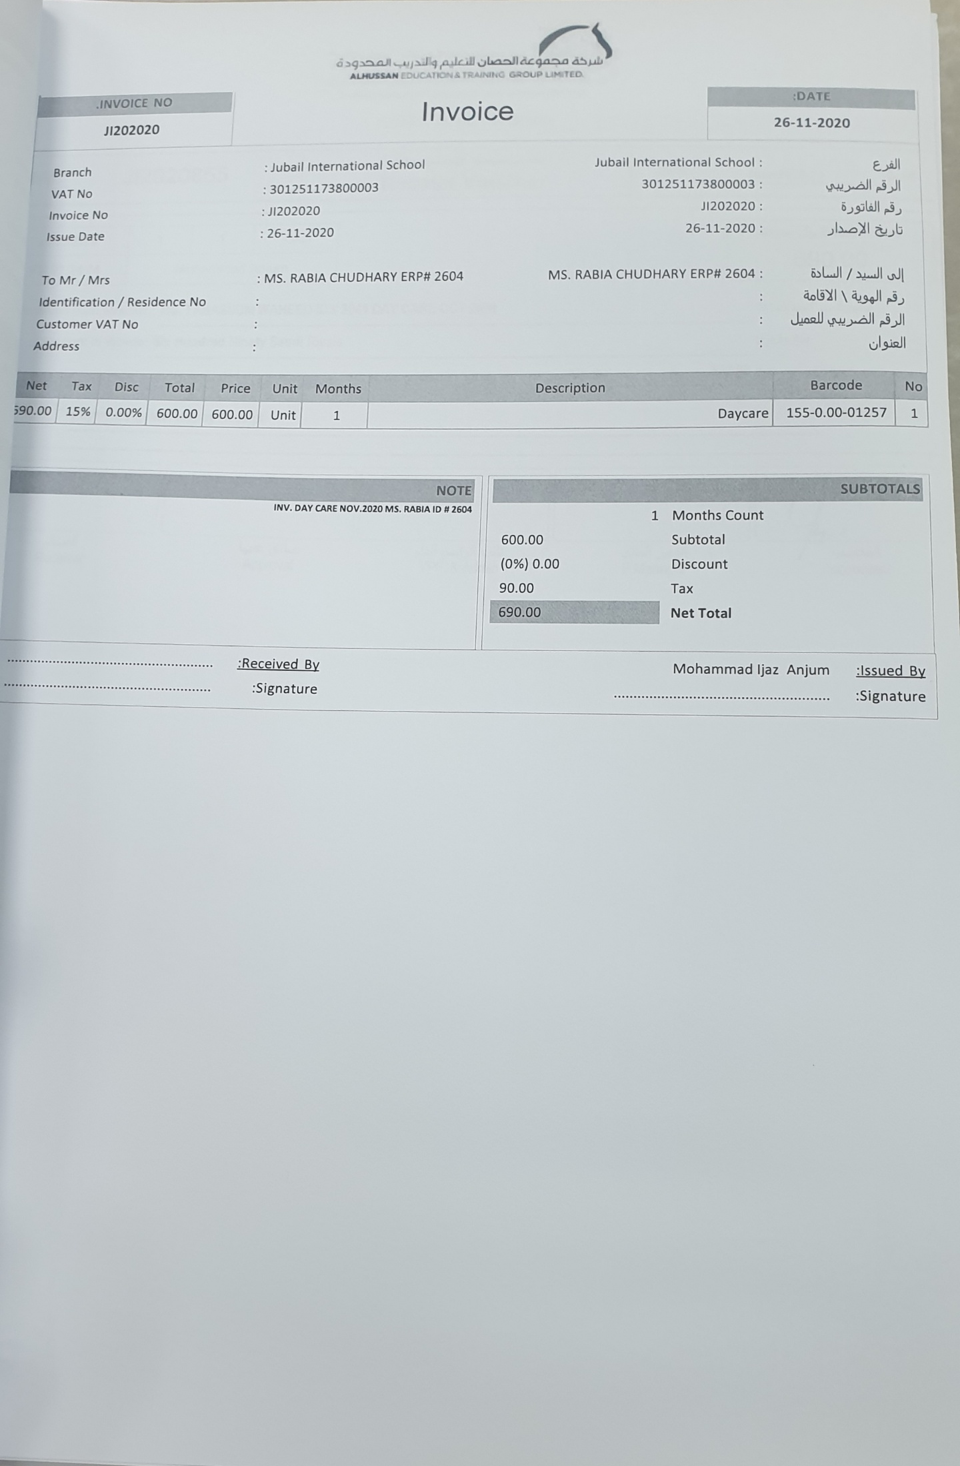
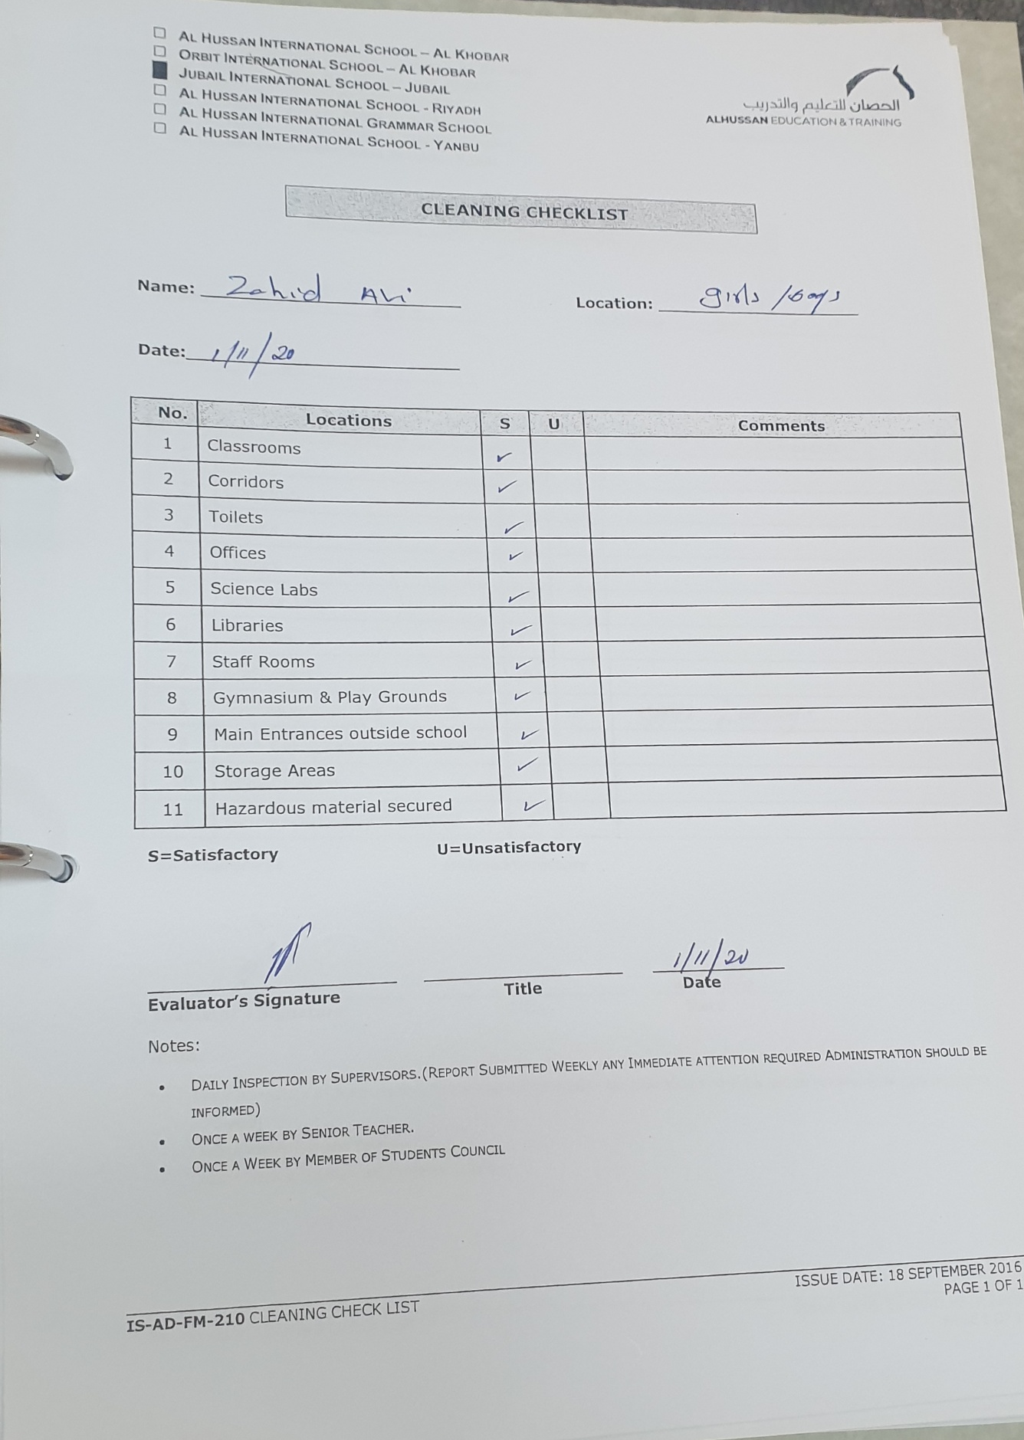

BM

Analysis documents by qms
